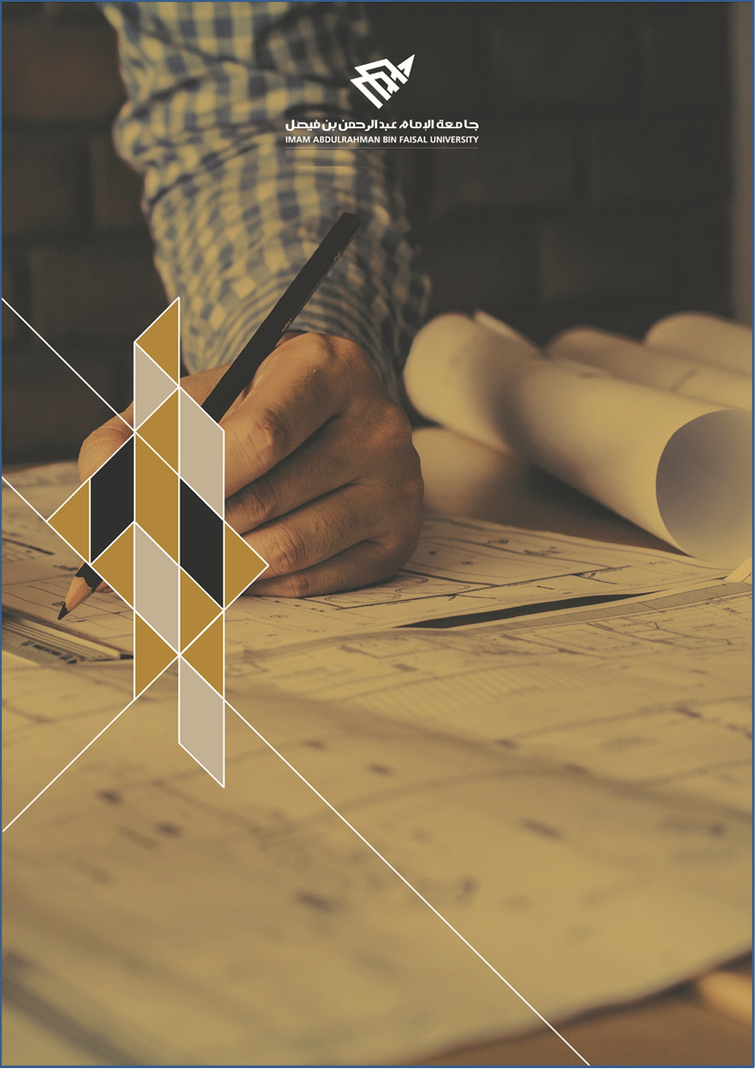
ARTI 404 – Image Processing

STUDENT PROCEDURAL MANUAL Lab 3

2025 - 2026
DEPARTMENT OF COMPUTER ENGINEERING

College of Computer Science and Information Technology
كلية علوم الحاسب وتقنية المعلومات

Session Topic/Title | Session No. | Session Duration (Minutes)
Image Manipulations using OpenCV Library | 3 | 150

- Session Outcomes

Outcome#1:
Explain how digital images are represented and manipulated in a computer.
Apply some geometric transformations to the images.
- Tool(s)/Software | .
- Python 3
- IDE for Python: Jupyter
- Libraries: OpenCV

- procedural steps (Tasks)

Step#1: Read an image using the OpenCV library
If you run the preceding program, you will see an image being displayed in a new window.
import cv2
img = cv2.imread('./images/input.jpg')
cv2.imshow('Input image', img)
cv2.waitKey()

Also, if you open up the Python shell and type the following, you will see the datatype printed on the terminal:
>>> import cv2
>>> img = cv2.imread('./images/input.jpg')
>>> type(img)

Step#2: Load an image

To convert a color image in grayscale mode. This operation is performed while reading the image

import cv2
gray_img = cv2.imread('images/input.jpg', cv2.IMREAD_GRAYSCALE)
cv2.imshow('Grayscale', gray_img)
cv2.waitKey()

Step#3: Save an image.
The below code of OpenCV is used to save an image file.
cv2.imwrite('images/output.jpg', gray_img)

Step#4: Convert an image to different color spaces
If you already read an image and want to convert it into GrayScal. You can use the below code.
import cv2
img = cv2.imread('./images/input.jpg')
gray_img = cv2.cvtColor(img, cv2.COLOR_BGR2GRAY)
cv2.imshow('Grayscale image', gray_img)
cv2.waitKey()

Considering all the color spaces, there are around 190 conversation options available in OpenCV. If you want to see a list of all available flags,
The following code will display all the options available in Open-CV related to color handling.

import cv2
print [x for x in dir(cv2) if x.startswith('COLOR_')]

You can convert to YUV by using the following flag: (YUV is another color model used to display color for Televisions. Y: physical linear-space brightness, U: blue projection, V: red projection.

yuv_img = cv2.cvtColor(img, cv2.COLOR_BGR2YUV)

To separate out the three channels, write the following lines:
cv2.imshow('Y channel', yuv_img[:, :, 0])
cv2.imshow('U channel', yuv_img[:, :, 1])
cv2.imshow('V channel', yuv_img[:, :, 2])
cv2.waitKey()

- Assessment

Task1: Use any image processing library and apply the following geometric transformations over the image.
- Increase the size of the image.
- Rotate the image by 120 degrees.
- Perform Sheer operations over the image.

Task2: Use any image processing library and apply the following intensity transformations over the image.
- Negative
- Log with (choose an appropriate constant for your image)
- Power law (choose a value for gamma that increases the contrast)

- Resources

https://www.geeksforgeeks.org/image-transformations-using-opencv-in-python/

https://www.thepythoncode.com/article/image-transformations-using-opencv-in-python

https://medium.com/@khanhson0811/basic-intensity-transformation-functions-and-example-with-opencv-1a56932f34ac

Submission

The students need to prepare the report in a PDF format and submit the GitHub link via Blackboard. Make sure the Lab#3 folder contains the following files.

- Jupyter notebook
- Images used

